Page 80 of POWER CONVERSION AND CONTROL OF WIND ENERGY SYSTEMS by BinWu and Yongqiang Lang

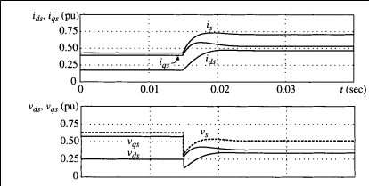

$$R_{L}= \frac{v_{ds}}{i_{ds}} = \frac{v_{qs}}{i_{qs}}$$

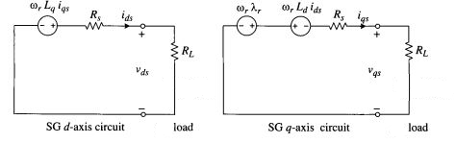

From the graphs of vds (initial value is estimated to be 0.25 p.u. and final value is almost 0.35 p.u.) and ids (initial value is estimated to be 0.16 p.u. and final value is almost 0.45 p.u.),

$$R_{L}= \frac{v_{ds,initial}}{i_{ds,initial}} = \frac{0.25}{0.16}=1.56 p.u.$$

$$\frac{R_{L}}{2}= \frac{v_{ds,final}}{i_{ds,final}} = \frac{0.35}{0.45}=0.77 p.u.$$

From the graphs of vqs (initial value is estimated to be 0.6 p.u. and final value is almost 0.4 p.u.) and iqs (initial value is estimated to be 0.4 p.u. and final value is almost 0.55 p.u.),

$$R_{L}= \frac{v_{qs,initial}}{i_{qs,initial}} = \frac{0.6}{0.4}=1.5 p.u.$$

$$\frac{R_{L}}{2}= \frac{v_{qs,final}}{i_{qs,final}} = \frac{0.4}{0.55}=0.73 p.u.$$

Hence $R_{L}$ ≈1.5 p.u. (6 Ohm)

Page 82 of POWER CONVERSION AND CONTROL OF WIND ENERGY SYSTEMS by BinWu and Yongqiang Lang

Steady-State Analysis of Stand-Alone SG with RL Load.





In this case

$$L_{L}=0$$

iqs=((w*7.030056*(6+Rs))/((6+Rs)*(6+Rs)+w*w*Ld*Lq))= 262.7145

iqs_pu=iqs/(490*sqrt(2))= 0.3791 p.u.

ids=((w*Lq*iqs)/(Rs+6))= 114.7591

ids_pu=ids/(490*sqrt(2))= 0.1656 p.u.